We all love our pets but please remember to be respectful of your neighbors and keep dogs on a leash at all times when outside. You also need to pick up after your dog when taking them for walks. It’s the right thing to do!

Vacation Safety
Summer is here and vacation time is near. As you plan your time away, be sure to stop papers and mail and notify your neighbors of your time away to keep a watchful eye on things for you. Communication is key in helping cut down on crime in our community.
New Board Officers

President…..…Randy Larsen
V. President….David Clark
Secretary…….Carrie McRay
Treasurer…….Ruth Charlson
At Large Rep…Luis Salom

Next Meeting – July 7th

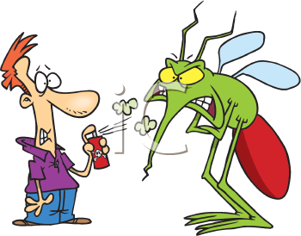

Kids Are Out of School!

Neighborhood
Notices
Street Light Outages:
713-207-2222
Be sure to have light pole number or go to www.centerpointelectric.com

Sidewalk Damage:
281-420-5300

Parking in Street:
This is a violation of City Ordinance Code 94-189 adopted in 2008 which requires all licensed, inspected, operable vehicles to be parked in driveways, side yards, or back yards of the residence.
To report: 281-420-5384

Mosquito Control

With our recent rains we need to be aware of emptying, removing, or turning upside down any containers that can hold water. Also be sure to clean clogged roof gutters.
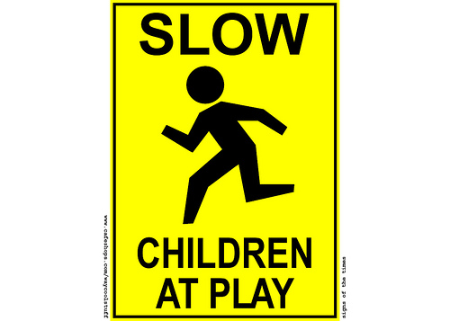
When outside remember to wear light-colored clothing, long sleeves and pants. Apply insect repellant to clothing and sparingly to skin. The most effective repellant contains DEET. Keep grass mowed also. Call the City of Baytown Health Department at 281-420-5384 if you need mosquito spraying.

Brush Pick Up

When pruning trees and shrubs, remember brush pick up is once a month. You can call 281-420-5384 to find out exactly when pick up times are.
If you have building materials, large sections of carpet, fencing or scrap metal, you may take those items to the Baytown Green Center at 160l W. Main (281-420-5300) or the Waste Management Landfill Site Monday – Saturday (281-383-2454).
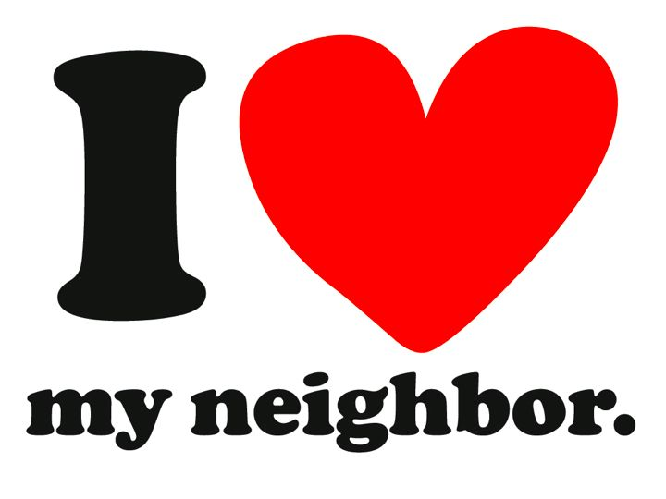

Fly your Flag: June 14 – Flag Day
July 4th – Independence Day

Join Nextdoor Neighbor
Join Nextdoor Neighbor.

