October, 2018
Volume 8 Issue 1

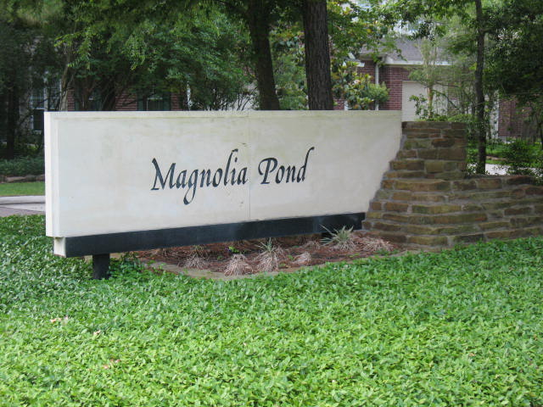

Is managed by:
JDH Property Management Co.
PO Box 96046
Houston, TX 77213
1776 Woodstead Ct.
The Woodlands, TX 77380
Phone: 281-296-7000
FAX: 281-882-8086
Toll free 888-454-2108

Our property manager is:
Laurie Oliver
Phone: 281-695-1037
laurieo@jdhamc.com

WEB Site: jdhamc.com

Magnolia Pond

FALL NEWS LETTER

BOARD ELECTION - NOVEMBER

Three board positions are up for election this November. Any owner-resident is eligible to run for one of these positions. This is an opportunity to represent your neighbors and help with the decisions that make our community what it is. Keep in mind that everyone’s active participation and involvement in the “business” of Magnolia Pond is really important if we are to keep our neighborhood a vibrant and desirable home destination in the years ahead. Please let Laurie Oliver at JDH know if you would like your name added to the ballot.

The election will take place at our November 14th Annual Meeting at the Forum. Registration begins at 6:45 PM, and the meeting will start at 7:00 PM. Mark your calendars and plan to be there!

2018 PROJECTS

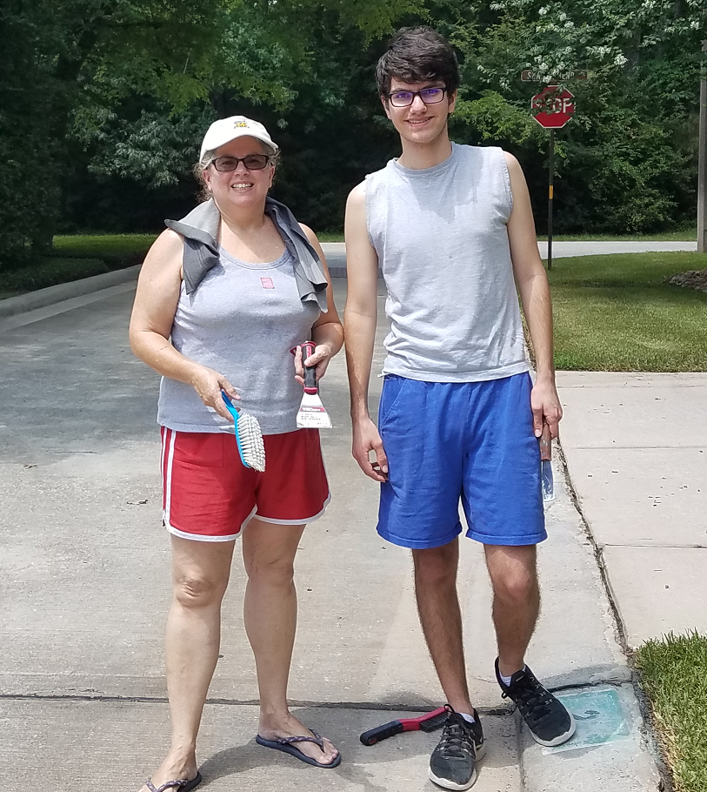

Some of the people who worked hard for us this Summer

The projects commissioned by the Board of Directors in 2018 were targeted at maintaining and keeping our community looking bright and clean. In addition to routine gutter cleaning, these projects included refurbishing and repainting the steps for all upstairs units, power washing the buildings, driveways and sidewalks, followed by repainting unit numbers on the curbs.

In Closing: We live in a condominium community and are bound by rules that make living close together safe, more pleasant and comfortable. If you need a copy of these rules, please call JDH Property Management and they will provide one. Also, be sure you make JDH aware of any changes in your email address or telephone number. See you at the Annual Meeting!

